The goal of t-SNE to take a set of points in a high-dimensional space and find a faithful representation of those points in a lower-dimensional space, typically the 2D plane.

Here we know that there is concept of neighbourhood for the elements which are geometrically closer, so what t-SNE does is whatever the distance of points in same neighbourhood in d-dimension, it will preserve that distance in 2-D also.

But it does not preserve the distance of points which are not neighbourhood.

Example: In below fig neighbourhood of x1 are x2 and x3, neighbourhood of x4 is x5, so while representing these points from d dimensions to 2-D, t-SNE will preserve the distance of (x1, x2), (x1, x3), (x4, x5), since these points are neighbourhood, but t-SNE doesn’t preserve the distance of (x1,x4) or (x1, x5).

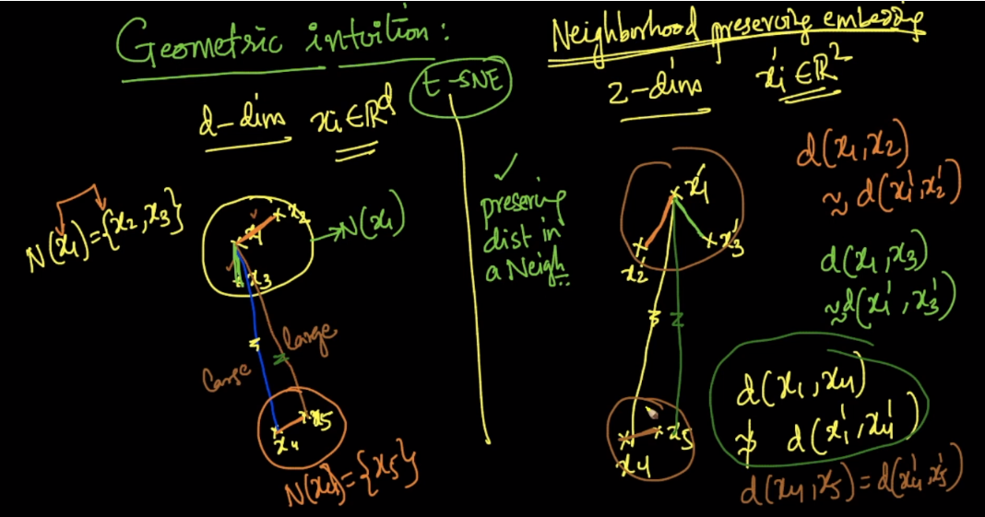

Comments:

* How you are deciding that neighborhood is X1 it should lie in the center of the point or any other reason if I tell X2 is the neighborhood of X1 and X3 bcoz these 2 also very near to X2 is it correct statement.

we are calculating distance from X1 to all other points and considering only those points as neighbours of X1 which fall in to specific radius from X1(say radius is 5cm) all points which are less then or equal to 5cms from X1 are considered as neighbours of X1 and X1 lies in the center of this circle.Similarly for all other points we calculated neighbours

* TSNE does nothing more than maintaining clusters from n-dimension to lower dimensions. So Assuming all our datapoints for each digits 1,2,3 etc are isolated clusters in n-dimension it maintains that geometry by transforming it into 2d isolated circles.Hence better visualization
* sne only preserves the distance between its neighbouring points....but the angle between two points is also important.So, does tsne preserve that also?

No, it’s only the distance.

* Suppose g1=(x1, x2, x3) are together and g2=(x4, x5) is together. But g1 and g2 are far from each other. Since t-SNE doesn't preserve the distance between g1 and g2, suppose if it places g1 and g2 together in the 2D space, how will we identify this difference?

yes it will be possible thats why you cannot make any inference based only on the output of t-SNE. So essentially it is mainly a data exploration and and visualization technique as it group similar points together(preserve local structure).